Scan Distribution - 3rd Party Developer's Guide

The information contained in this document is confidential and proprietary to Tire Profiles LLC and its affiliates (collectively “Tire Profiles”). No part of this document may be distributed or disclosed in any form to any third party without written permission of Tire Profiles.
© 2016-2019 Tire Profiles LLC All rights reserved.

Table of Contents
Revision History 2
Terms and Definitions 4
Overview 5
Endpoint Specification 5
Scan Distribution Endpoint Versioning 6
Live Testing During Development 6
3rd Party Development Assets 7
JSON Examples 7
Appendix A– FAQ 8
Appendix B – Tire Position Definition 9
Commercial Motor Vehicles 9

Revision History
Name | Date | Comment
Chip Bergquist | 2017-07-10 | Initial draft
Chip Bergquist | 2018-02-05 | JSON v4.0 changes including:  - Result property eliminated.  - Assorted property name changes to support legibility and naming standards.  - Corrected schema for issues with arrays of objects.  - TreadTrackerReport property is now required.  - Clarified that properties should always exist with the option to be null.  - Corrected required and not required data for Vehicle Details, VIN and Year specifically, and all others with minor refactoring.  - Added data elements for:  - TPIDealerName  - TPIDealerID  - JSONVersion  - MACAddress  - SerialNumber  - VehcileHasWinterTires  - GrooveDepths  - GroovePositions  - CustomDealerContent
Chip Bergquist | 2018-06-28 | JSON v4.1 changes including:  - Added GDPR Message Support  - Added Message Security Support
Chip Bergquist | 2019-01-28 | JSON v4.2 changes including:  - Added l10n and i18n Support for Messages  - Added UnitID for CMV.
Chip Bergquist | 2019-05-01 | JSON v5.0 changes including:  - Added CustomerDealerID

Terms and Definitions
3rd Party – An entity outside Tire Profiles of one of its subsidiaries or partner companies that wants to integration to scans through Scan Distribution.
CMV – Commercial Motor Vehicle. Shorthand for the TPI Groove Glove product that supports “16 Wheeler”, over-the-road Tractors and Trailers.
Dealer – TPI uses the term dealer to represent the physical location where the scanning equipment is being used.
Groove Glove – A handheld TPI tire scanning product. An example of scanning equipment.
JSON – (JavaScript Object Notation) is a lightweight data-interchange format. It is easy for humans to read and write. It is easy for machines to parse and generate.
TreadTracker Report – The printed report given to a vehicle owner by the service center showing the results from scanning equipment.
Scan Distribution – A process where scan information is sent to a 3rd Party endpoint for a variety of possible reasons including DMS Integration, Value Added product development, corporate reporting, or any of many possible uses.
Scanning Equipment – TPI provided hardware for scanning tire. Groove Glove, Service Bay and Service Drive are three examples of scanning equipment.
Service Bay – A TPI tire scanning product where the vehicle drives over the system and must stop over each axel to be scanned. An example of scanning equipment.
Service Drive – A TPI tire scanning product where the vehicle drives over the system without stopping be scanned. An example of scanning equipment.
Vehicle Inspection – A TPI product for the Groove Glove that permits recording of a complete vehicle inspection and printing a report with the results.
Version – The current version of the Scan Upload JSON Schema is v5.0.

Overview
Scan Distribution is the name of the TPI process for disseminating the data used to create a TreadTracker report in a computer readable form. When configured, each scan that results in a TreadTracker report is sent via Scan Distribution to a 3rd Party provided endpoint configured on the TPI dealer’s behalf. This document, and the associated 3rd Party Development Assets, form the basis of the specification for the endpoints that receive the scan data. This document is intended to provide direction for 3rd Parties in developing these endpoints.
Scan Distribution is also used to send requests to remove personal data for a user. This is in support of the EU’s General Data Protection Regulation (GDPR).

Endpoint Specification
There are three requirements for the Scan Distribution endpoint:
- Scan Distribution data will be sent to the endpoint using HTTP or HTTPS POST.
- The payload of the post call will be a JSON document conforming to the appropriate version of the Scan Distribution Request Schema.
- Dealer specific information must be passed on the URL. If required, the TPI dealer identifier is in the JSON document as well.
If the endpoint meets those three criteria, the system will work. There are two common ways of implementing these endpoints:
- URL
  - http://domain.name.com/apiV5.0/ScanDistribution/<<DealerID>>
- Query Arguments
  - http://domain.name.com/apiV5.0/ScanDistribution?dealer=<<DealerID>>
Our system can handle both approaches.
Note:
- http://domain.name.com
  - Is the domain for the URL. It would be whatever the 3rd Party developer dictates.
- apiV5.0/ScanDistribution
  - Is the service. Again, as defined by the 3rd party vendor.
- <<DealerID>>
  - Is the 3rd Party vendor’s internal dealer identifier.
The 3rd Party vendor would need to provide TPI with the dealer specific URL to configure Scan Distribution.

Scan Distribution Endpoint Versioning
The observant reader will notice that the service name above contains “apiV3”. The Scan Distribution specification has undergone revision to add new data elements and organization.
- The current version of the Scan Upload JSON Schema is v5.0.
It is highly recommended that endpoints use API Versioning. This way, support for future versions can be more easily accomplished.

Live Testing During Development
Also note that we can use the live TPI system to send scan distribution messages to Development, QA, Alpha and/or Beta systems. If the endpoint responds appropriately with the correct schema, the fact it Is not a production system will not impact the TPI system.

3rd Party Development Assets
The following assets are available for your use:
- Scan Distribution - 3rd Party Developer's Guide
  - This document.
- Scan Distribution - Request - Schema v5.0.json
  - A JSON schema definition for the request to be processed by the endpoint.
  - All sent requests will be recoded for diagnostic purposes.
- Scan Distribution - Response - Schema v5.0.json
  - A JSON schema definition for the response to be sent by the endpoint.
  - All failed responses will be recorded for diagnostic purposes.
    - Note: No message parsing will occur to determine why a request failed.
- Request and Reponses JSON Examples
  - A variety of JSON examples.

JSON Examples
Not all scans have all types of data that could be collected by the system. Specifics of what can be collected and included in Scan Distribution can be found in the schema document. For 3rd Party testing prior to live testing, we have assembled several example requests.
- Scan Request - Minimum – v5.0.json
  - This example represents the absolute smallest file that could be sent by our system.
  - It is a scan from a glove with a single tire and no manually entered data.
  - This file would only be useful for testing to assure the endpoint handles the lack of data provided in each case properly.
- Scan Request - All Data – v5.0.json
  - This example represents the absolute smallest file that could be sent by our system which includes every type of data that could be sent.
  - It is a scan from a glove with a single tire, manually entered data at the tire and vehicle level, license plate image data and barcode data.
  - This file would only be useful for testing to assure the endpoint handles every possible piece of data that can be provided.
- Delete Scan Request – v5.0.json
  - This example represents the message you will receive when requesting to delete customer data.

Appendix A– FAQ
How do I ask for a scan to be sent to me?
This is the most common misunderstanding with this system. As a 3rd Party, you do not request scans. We send them to you when they are ready. You, as the 3rd Party write the endpoint described, it is not the one you call. You won’t call anything in our system.
What happens if I miss a scan that was sent?
Scan Distribution only supports sending scans as they occur. There is no queuing, retry or resend support.
How can I secure the data being sent?
Scan Distribution endpoints can be secured with:
  - HTTPS
  - Basic Authentication
  - X-Authentication
  - No other security models are supported at this time.
Can I get a batch upload of scans each day instead of as they come in?
Scan Distribution does not support a batch mode.

Appendix B – Tire Position Definition
Tire Position in the Scan Distribution JSON is represented with a character specifying the axle, starting with ‘A’ on the forward-most/front axle, ‘B’ for the second, etc. Tires are added from the vehicle centerline out with odd numbered tires on the left and even on the right.
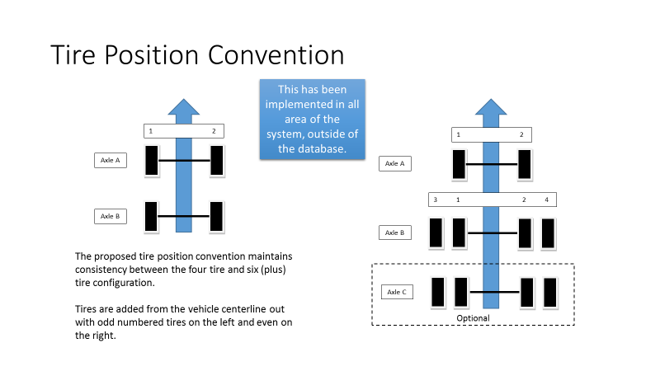

Commercial Motor Vehicles
Commercial Motor Vehicles (CMV) follow the same convention as demonstrated by:
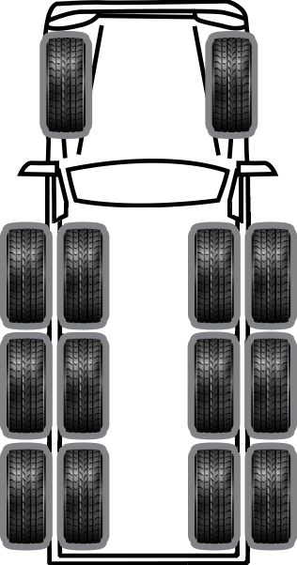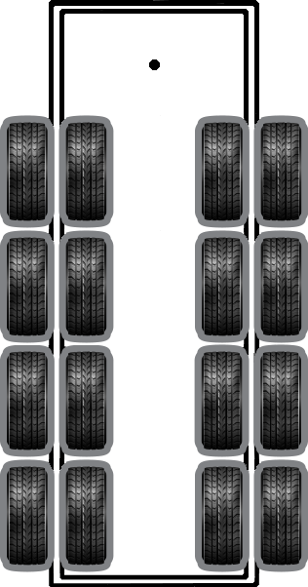
Trailer
Tractor
D2
C2
B2
A2
A1
B1
C1
D1
A3
B1
B3
C3
D3
D4
C4
B4
A4
D4
D3
C4
C1
C3
B3
B2
B4
D2
C2
D1
A2
A1

